FORTUNATI DESIREE 5’ACC

15-20 day motorbike tour (from 12 may to 29 may)
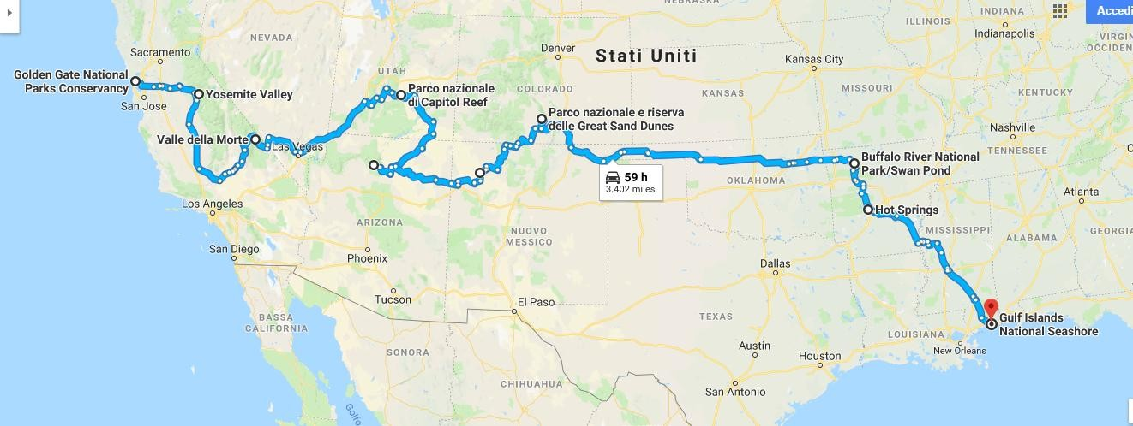
FLIGHTS
ALASKA AIRLAINES
12 may 2019
NEW YORK (JFK) → SAN FRANCISCO (SFO)
07.45 am (6h 26min) 11.10 am
Total for 2 passengers $342.60 (including taxes) 29 may 2019
NEW ORLEANS (MSY) → NEW YORK (JFK)
7.20 pm (3h 12min) 11.32 pm Total for 2 passengers $180,60 (including taxes) TRANSFER
12 may 2019
From San Francisco Airport to Motorbike Shop Rental ( 16 min. by shuttle) Total price for 2 people : $ 31,50

28 may 2019
From Hilton New Orleans to New Orleans Airport (20 min. by shuttle) Total price for 2 people : $ 56,64

RENT MOTORBIKE EAGLE RIDER
Pickup motorcycles → 3146 Mission St., San Francisco, CA 94110, United States 12 may 2019 at 2.00 pm

Place of issue → 2428 Williams Blvd, Kenner, LA 70062, United States 28 may 2019 at 12.00 pm
First motorbike : HARLEY-DAVIDSON STREET GLIDE (GPS included) Rental (16 days) → $ 1.904
Environmental Surcharge (16 days) → $ 123,76 Roadside assistance (16 days) → $ 159,68 Drop Off supplement → $ 595
Taxes → $ 236,51
TOTAL PRICE → $ 3.018,95

Second motorbike: HARLEY-DAVIDSON STREET GLIDE (GPS included)

Rental (16 days) → $ 1.904
Environmental Surcharge (16 days) → $ 123,76 Roadside assistance (16 days) → $ 159,68 Drop Off supplement → $ 595
Taxes → $ 236,51
TOTAL PRICE → $ 3.018,95

ACCOMMODATION

12-13 MAY ( GOLDEN GATE)
Hotel Beresford 635 Sutter Street, Union Square, San Francisco, CA
-Breakfast included
Total price for 2 people for 2 nights → $ 393

14 MAY (YOSEMITE VALLEY)
Yosemite View Lodge 11136 Highway 140, El Portal, CA ( 16,8 km from Yosemite Valley) Total price for 2 people for 1 night → $ 315

15 MAY (DEATH VALLEY)
Death Valley Inn & RV Park 651 Highway 95 South, Beatty, NV Total price for 2 people for 1 night → $ 95

16 MAY (ON ROAD)
Delight’s Hot Springs Resort 368 Tecopa Hot Springs Road, Tecopa , CA Total price for 2 people for 1 night → $ 112

17 MAY (CAPITOL REEF)
Broker Spur Inn & Steakhouse 955 East SR – 24, Torrey, UT
-Breakfast included
Total price for 2 people for 1 night → $ 175

18 MAY (ON ROAD)
Rodeway Inn & Suites Lake Powell-Page 605 South Indipendence Drive, Big Water, UT
-Breakfast included
Total price for 2 people for 1 night → $ 119

19 MAY ( GRAND CANYON SOUTH ENTRANCE ROAD)
Grand Canyon Plaza Hotel 406 Canyon Plaza Lane, Tusayan, AZ Total price for 2 people for 1 night → $ 243

20 MAY (ON ROAD)
Red Roof Inn Gallup 3304 West Hwy 66, Gallup, NM
-Breakfast included
Total price for 2 people for 1 night → $ 44

21 MAY ( CHACO CULTURE)
Chama River Bend Lodge 2625 Highway 84-64, Chama, NM Total price for 2 people for 1 night → $ 134

22 MAY (GREAT SAND DUNES)
Lamp Post Lodge 59450 Colorado 69, Westcliffe, CO Total price for 2 people for 1 night → $ 127

23 MAY (ON ROAD)
Hampton Inn Fort Smith 6201-C Rogers Avenue, Fort Smith, AR
-Breakfast included
Total price for 2 people for 1 night → $ 97

24 MAY (BUFFALO RIVER)
Misty Bluff Hwy 7 South, Jasper, AR
Total price for 2 people for 1 night → $ 140

25 MAY (HOT SPRINGS NATIONAL PARK)
Springs Hotel and Spa 135 Central Avenue, Hot Springs, AR Total price for 2 people for 1 night → $ 108

26-27 MAY (GULF ISLANDS)
Scarlet Pearl Casino Resort 9380 Central Avenue, Biloxi, MS Total price for 2 people for 2 nights → $240

28 MAY (NEW ORLEANS)
Hilton New Orleans/ St. Charles Avenue 333 Saint Charles Avenue, New Orleans, LA
Total price for 2 people for 1 night → $ 148

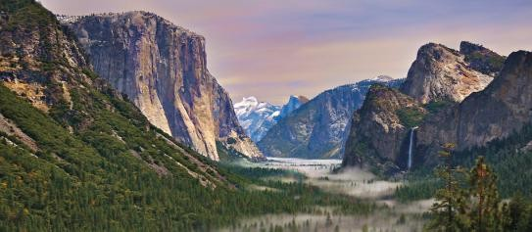
TOUR

4h 9min
Golden Gate Yosemite Valley

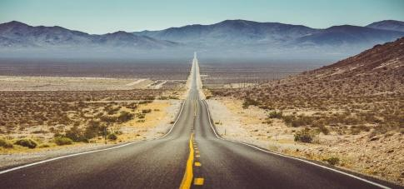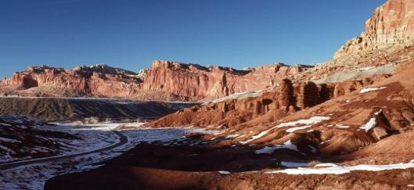7h 32min
Yosemite Valley Death Valley

7h 19min
Death Valley Capitol Reef

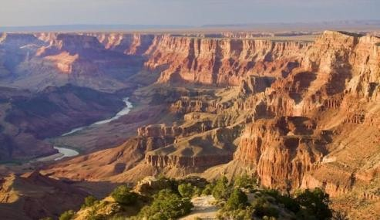
5h 39min
Capitol Reef Grand Canyon South Rim

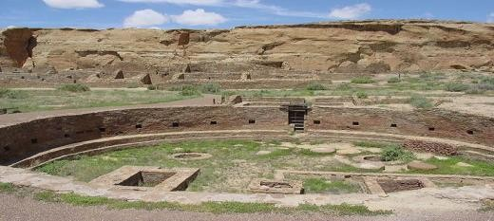
5h 36min
Grand Canyon South Rim Chaco Culture

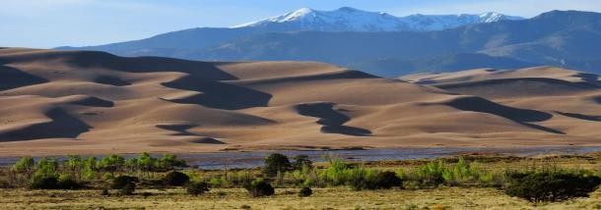
4h 45 min
Chaco Culture Great Sand Dunes

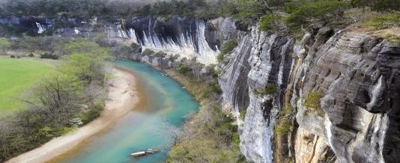
13h 27 min
Great Sand Dunes Buffalo River

3h 9min 7h 59min
Buffalo River Hot Springs Gulf Islands.

 | PRICE PER PERSON | PRICE FOR 2 PEOPLE
FLIGHTS | $ 261,60 | $ 523,20
ACCOMODATION | $ 1.245,00 | $ 2.490,00
RENT MOTORBIKE | $ 3.018,95 | $ 6.037,90
TRANSFER | $ 44,07 | $ 88,14
TOTAL | $ 4.569,62 | $ 9.139.24
MARK UP 25% | $ 2.284,81

