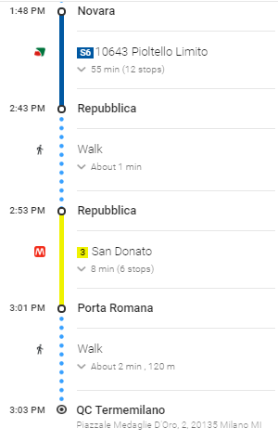

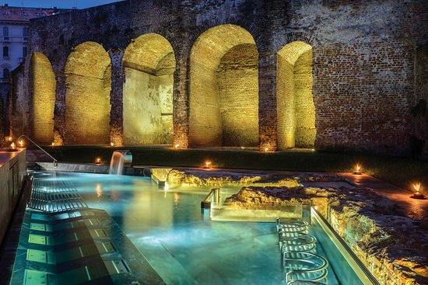

**BY CAR**

**From Novara take A4**

**Follow A4/E64, A50/E35/E62 and A7 to Via Spezia in Milano**

**Continue on Via Spezia. Take SP11 to Viale Angelo Filippetti**

If you treat your body well,

it can last a lifetime.

N. Clarasò

**Piazzale Medaglie D’Oro, 2 20135 Milano**

**Phone** [**+39 0255 199367**](tel:+39%200255%20199367)

**E-mail:** [**reception@termemilano.com**](mailto:reception@termemilano.com)

* **MONDAY-FRIDAY 48€ per person (massages not included)**
* **SAT-SUN-PUBLIC HOLIDAYS 54€ per person (massages not included)**

**DAY SPA**

* **Day spa 25 🡪 entrance and 25min. massage €88**
* **Day spa 50 🡪 entrance and 50min. massage €118**
* **Day spa 75 🡪 entrance and 75min. massage €142**
* **Couple’s day spa 🡪 entrance and couple massage €238**
* **“10 plus massages “🡪 50min. massage each €728**

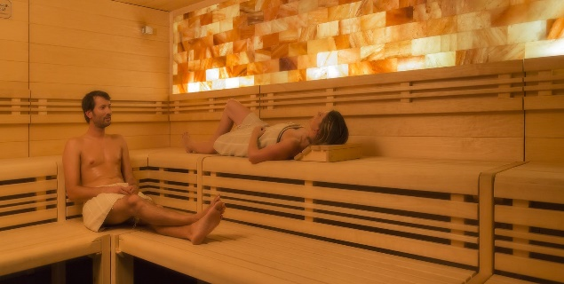

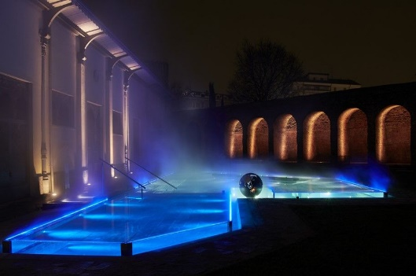

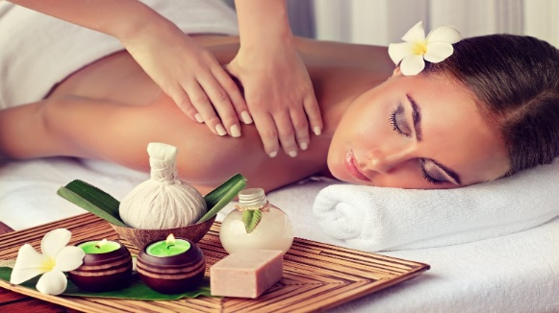

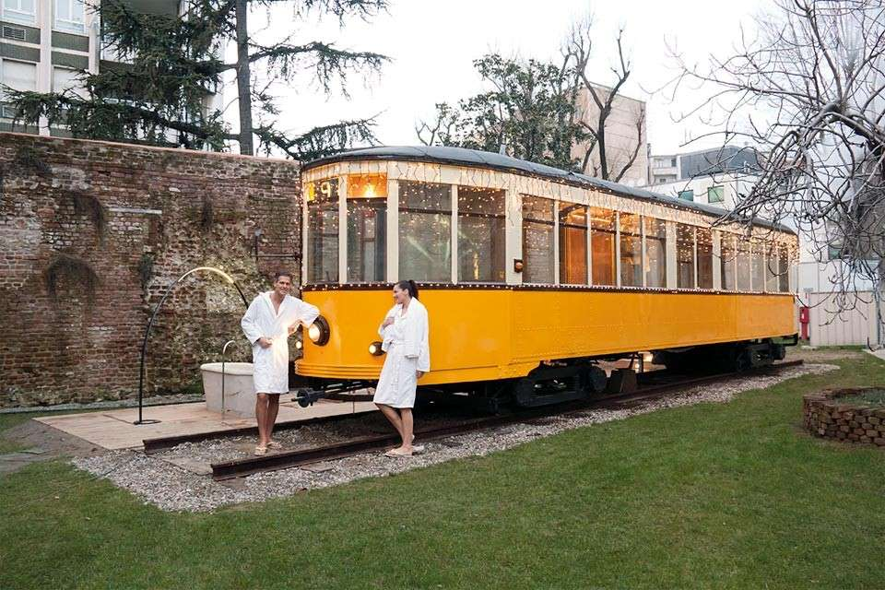

**OPENING TIMES**

**MONDAY-FRIDAY 9.30-00.00**

**SAT-SUN-PUBLIC HOLIDAYS 8.30-00.00**

**TREATMENTS**

* **Hydro massages tubs and hydrojets**
* **Waterfalls and sensorial bath tubs**
* **Salt room**
* **Saunas and steam bath**
* **Relaxation rooms**
* **Olfactory experience**
* **Wellness tram**
* **Massages**